**Rossett Reading**

Recommendations from the Learning Resource Centre.

**Book of the Week**

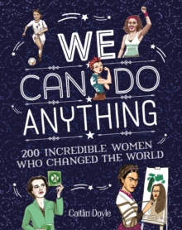

From sports to innovation, art to politics - meet the incredible women who got there first!

Did you know that the first computer programmer was a woman? Countess Ada Lovelace (1842). Or that the inventor of the life raft, windshield wiper, and Kevlar were all female? Discover lots of inspiring stories.

**Sixth Form Book of the Week**

Yvette Cooper MP tells the rousing story of female voices that have inspired change, transformed lives and altered history by gathering brilliant speeches by women throughout the ages, from Boudica to Greta Thunberg and Malala; an inspirational call for women to be heard across the globe.

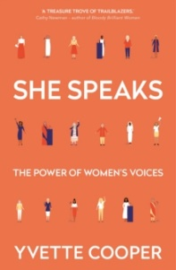

**Fiction choice – strong female characters**

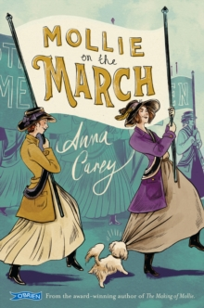

Mollie and her best friend Nora have been bravely fighting for women's rights so when they hear a big protest is being planned, they know they must take part. If only they didn't have to worry about Nora's terrible cousin, her awful brother and her neighbour's very annoying dog. An engaging story about a strong and intelligent girl fighting for the right for women to vote. (Suitable for younger readers)

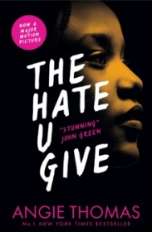

Sixteen-year-old Starr lives in two worlds: the poor neighbourhood where she was born and raised and her posh high school in the suburbs. The uneasy balance between them is shattered when Starr is the only witness to the fatal shooting of her unarmed best friend, Khalil, by a police officer.

Inspired by the Black Lives Matter movement, this is a powerful and gripping YA novel about one girl's struggle for justice. (Suitable for older readers)

All the books featured are available to borrow from Rossett LRC. For more information or book recommendations please contact LRC@rossettschool.co.uk